

DEPARTMENT OF COMPUTER SCIENCE AND ENGINEERING

LAB MANUAL



U23CSP33 -OBJECTORIENTEDPROGRAMMINGLABORATORY

REGUALTION: 2023

Prepared By Approved By

U20CSP33 OBJECTORIENTEDPROGRAMMINGLABORATORY L T PC
00 42

COURSE OBJECTIVES
Tobuildsoftwaredevelopmentskillsusingjavaprogrammingforreal-worldapplications.
To understand and apply the concepts of classes, packages, interfaces, arraylist, exceptionhandlingandfile processing.
Todevelopapplicationsusinggenericprogrammingand eventhandling.

LISTOFEXPERIMENTS
- Develop a Java application to generate Electricity bill. Create a class with the followingmembers: Consumer no., consumer name, previous month reading, current month reading, typeof EB connection (i.e domestic or commercial). Compute the bill amount using the followingtariff.

If the type of the EB connection is domestic, calculate the amount to be paid as follows:First100 units -Rs. 1 perunit
101-200 units - Rs. 2.50 per unit201-500 units -Rs. 4per unit
  - 501units -Rs. 6 per unit
If the type of the EB connection is commercial, calculate the amount to be paid as follows:First100 units -Rs. 2 perunit
101-200 units - Rs. 4.50 per unit201-500 units -Rs. 6per unit
  - 501units -Rs. 7 per unit

- Develop a java application to implement currency converter (Dollar to INR, EURO to INR,Yen to INR and vice versa), distance converter (meter to KM, miles to KM and vice versa), timeconverter(hours to minutes, seconds and viceversa) usingpackages.

- Develop a java application with Employee class with Emp_name, Emp_id, Address, Mail_id,Mobile_noasmembers.Inherittheclasses,Programmer,AssistantProfessor,AssociateProfessor and Professor from employee class. Add Basic Pay (BP) as the member of all theinherited classes with 97% of BP as DA, 10 % of BP as HRA, 12% of BP as PF, 0.1% of BP forstaffclub fund. Generatepayslips fortheemployees with theirgross and netsalary.

- DesignaJavainterfaceforADTStack.Implementthisinterfaceusingarray.Providenecessaryexception handlingin both the implementations.

- WriteaprogramtoperformstringoperationsusingArrayList.Writefunctionsforthefollowing
- Append- addat end
- Insert-add atparticularindex
- Search
- Listallstringstartswithgivenletter

- WriteaJavaProgramtocreateanabstractclassnamedShapethatcontainstwointegersandanemptymethodnamedprintArea().ProvidethreeclassesnamedRectangle,TriangleandCircle such that each one of the classes extends the class Shape. Each one of the classes containsonlythe method print Area() that prints the areaof thegivenshape.

- WriteaJavaprogramtoimplementuserdefinedexceptionhandling.

- Write a Java program that reads a file name from the user, displays information about whetherthe file exists, whether the file is readable, or writable, the type of file and the length of the file inbytes.

- Write a java program that implements a multi-threaded application that has three threads. Firstthreadgeneratesarandomintegerevery 1secondandifthevalueiseven,secondthreadcomputes the square of the number and prints. If the value is odd, the third thread will print thevalue ofcubeof thenumber.

- Write a java program to find the maximum value from the given type of elements using agenericfunction.

- Designacalculatorusingevent-drivenprogrammingparadigmofJavawiththefollowingoptions.
- Decimalmanipulations
- Scientificmanipulations

- Developa miniproject foranyapplication usingJavaconcepts.

TOTAL:60PERIODS
OUTCOMES
Uponcompletion ofthe course,the studentswill beable to
DevelopandimplementJavaprogramsforsimpleapplicationsthatmakeuseofclasses,packagesandinterfaces.
DevelopandimplementJavaprogramswitharraylist,exceptionhandlingandmultithreading.
Design applicationsusingfileprocessing,genericprogrammingandeventhandling.

DEPARTMENT OF COMPUTER SCIENCE AND ENGINEERING
Vision
To produce globally competent, socially responsible professionals in the field of Computer Science and Engineering.
Mission
- Impart high quality experiential learning to get expertise in modern software tools
- Inculcate industry exposure and build inter disciplinary research skills.
- Mould the students to become Software Professionals, Researchers and Entrepreneurs by providing advanced laboratories.
- Acquire Innovative skills and promote lifelong learning with a sense of societal and ethical responsibilities
Program Educational Objectives (PEOs)
PEO 1:Graduates of the program will develop proficiency in identifying, formulating, and resolving complex computing problems.
PEO 2:Graduates of the program will achieve successful careers in the field of computer science and engineering, pursue advanced degrees, or demonstrate entrepreneurial success.
PEO 3: Graduates of the program will cultivate effective communication skills, teamwork abilities, ethical values, and leadership qualities for professional engagement in industry and research organizations.
PROGRAM SPECIFIC OUTCOMES (PSO):
Graduates of B.E. Computer Science and Engineering will be able to:
PSO 1: Analyze, develop and provide solutions to industrial problems in computer domain using programming, data processing and analytical skills.
PSO 2: Apply software application-oriented skills to innovate solution to meet the ever-changing demands of IT industry.

DEPARTMENT OF COMPUTER SCIENCE AND ENGINEERING

Program Outcomes (POs):

PO1: Engineering knowledge: Apply the knowledge of mathematics, science, engineering fundamentals, and an engineering specialization to the solution of complex engineering problems.
PO2: Problem analysis: Identify, formulate, review research literature, and analyze complex engineering problems reaching substantiated conclusions using first principles of mathematics, natural sciences, and engineering sciences.
PO3: Design / development of solutions: Design solutions for complex engineering problems and design system components or processes that meet the specified needs with appropriate consideration for the public health and safety, and the cultural, societal, and environmental considerations.
PO4: Conduct investigations of complex problems: Use research based knowledge and research methods including design of experiments, analysis and interpretation of data, and synthesis of the information to provide valid conclusions.
PO5: Modern tool usage: Create, select, and apply appropriate techniques, resources, and modern engineering and IT tools including prediction and modeling to complex engineering activities with an understanding of the limitations.
PO6: The engineer and society: Apply reasoning informed by the contextual knowledge to assess societal, health, safety, legal and cultural issues and the consequent responsibilities relevant to the professional engineering practice.
PO7: Environment and sustainability: Understand the impact of the professional engineering solutions in societal and environmental contexts, and demonstrate the knowledge of, and need for sustainable development.
PO8: Ethics: Apply ethical principles and commit to professional ethics and responsibilities and norms of the engineering practice.
PO9: Individual and team work: Function effectively as an individual, and as a member or leader in diverse teams, and in multidisciplinary settings.
PO10: Communication: Communicate effectively on complex engineering activities with the engineering community and with society at large, such as being able to comprehend and write effective reports and design documentation, make effective presentations, and give and receive clear instructions.
PO11: Project management and finance: Demonstrate knowledge and understanding of the engineering and management principles and apply these to one’s own work, as a member and leader in a team, to manage projects and in multidisciplinary environments.
PO12: Life - long learning: Recognize the need for and have the preparation and ability to engage in independent and life-long learning in the broadest context of technological change.

Ex. No :1 GENERATING ELECTRICITY BILL

AIM:

To Develop a Java application to generate Electricity bill.

ALGORITHM:

- Import the java packages.
- Create a class with members Consumer no.,consumer name,previous month reading,current month reading,type of EB connection(i.e domestic or commercial).
  - Class also contains methods domestic billcalc and commercial billcalc with its parameters to compute bill amount.
- Check whether the type of connection is domestic or commercial. If domestic, calculate the bill amount as follows:
First 100 units - Rs. 1 per unit
101-200 units - Rs. 2.50 per unit
201-500 units -Rs. 4per unit
  - 501units -Rs. 6 per unit
If commercial, calculate the bill amount asfollows:
First100 units -Rs. 2 perunit
101-200 units - Rs. 4.50 per unit
201-500 units -Rs. 6per unit
  - 501units -Rs. 7 per unit
- Calculate the units consumed by finding the differences between previous month reading and current month reading.
- By using Scanner class get the input during runtime.
- Create object for a class in memory and assign it to the reference variable, then the method is invoked.
- Finally ,the bill amount is displayed based on type of connection.

PROGRAM:

//File Name should be Saved as Ebbill.java

import java.io.*;
import java.util.*;
class ElectricityBill
{
double bill;
double domesticbillcalc(intunits)
{
if(units<100)
bill = units * 1 ;
else if(units <=200)
bill = 100 * 1 + (units - 100) * 2.50; else if(units <=500)
bill = 100 * 1 + 200 * 2.50 + (units - 200) * 4;
else
bill = 100 * 1 + 200 * 2.50 + 500 * 4 + (units - 500) * 6 ;
return bill;
}
Double commercialbillcalc(intunits)
{
if(units<100)
bill = units * 2 ;
else if(units<=200)
bill = 100 * 1 + (units - 100) * 4.50 ;
else if(units <=500)
bill = 100 * 1 + 200 * 4.50 + (units - 200) * 6 ;
else
bill = 100 * 1 + 200 * 4.50 + 500 * 6 + (units - 500) * 7 ;
return bill;
}
void show(String ptype,String consno,String consname,int pmr,in tcmr,int units)
{
System.out.println("Type of Connection : " + ptype);
System.out.println("Consumer Number : " + consno);
System.out.println("Customer Name : " + consname);
System.out.println("PreviousMonthReading: "+pmr);
System.out.println("Current Month Reading: " + cmr);
System.out.println("UnitsConsumed : "+units);
}
}

Class Ebbill
{
public static voidmain(String[] args)
{
Scanner c = new Scanner(System.in); System.out.println("Enter the Type of Connection :"); Stringptype=c.next();
System.out.println("Enter the Consumer Number :"); Stringconsno=c.next();
System.out.println("EntertheConsumerName:"); String consname=c.next();
System.out.println("Enter the Previous Month Reading :"); int pmr=c.nextInt();
System.out.println("Enter the Current Month Reading :"); int cmr=c.nextInt();
int units =cmr-pmr;
ElectricityBill b = new ElectricityBill(); if(ptype.equalsIgnoreCase("DOMESTIC"))
{
b.show(ptype,consno,consname,pmr,cmr,units);b.domesticbillcalc(units); System.out.println("Billto pay:"+b.bill);
}
else if(ptype.equalsIgnoreCase("COMMERCIAL"))
{
b.show(ptype,consno,consname,pmr,cmr,units);b.commercialbillcalc(units); System.out.println("Bill to pay:"+b.bill);
}
}
}

NOTE:
To Compile,
javac Ebbill.java
To Run
java Ebbill

OUTPUT:
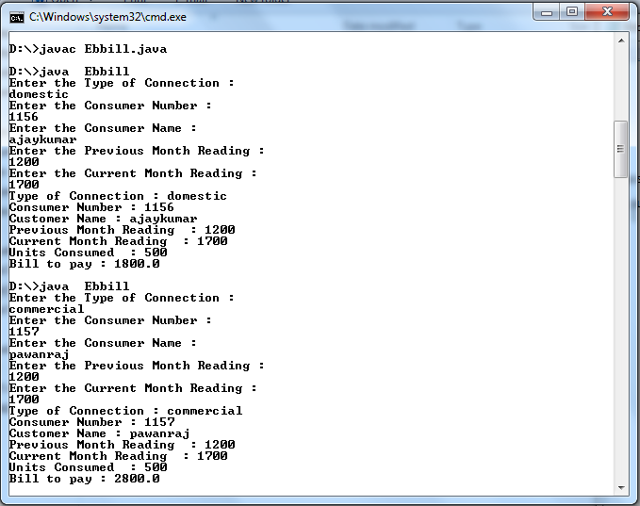

RESULT:

Thus the application for generating Electricity bill has been successfully executed.

Ex .no CURRENCY CONVERTER, DISTANCE CONVERTER AND TIME CONVERTER USING PACKAGES

AIM:

To develop a java application to implement currency converter,distance converter
And time converter using packages.

ALGORITHM:

- The package keyword is used to create a package in java.
- Create a class Currency Converter inside a package name Currency Converter.
- Class also contains methods dollor to inr, inr to dollor, euro to inr, inr to euro, yen to inr, and inr to yen with its parameters to convert given currency.
- Create a class Distance Converter inside a package name Distance Converter.
- Class also contains methods metertokm, kmtometer, milestokm and kmtomiles with its parameters to convert given distance.
- Create a class TimeConverter inside a package name Time Converter.
- Class also contains methods hourstominutes, minutestohours, hourstoseconds and seconds to hours with its parameters to convert given time.
- Import the CurrencyConverter, DistanceConverter, TimeConverter and other java packages.
- Create a class Converter and object for a class in memory and assign it to the reference variable,then the method is invoked.
- By using Scanner class get the choices for switch statement during runtime.
- By using switch case statement we can convert currency, distance and time for each choice.
- Create object for a class in memory and assign it to the reference variable, then the method is invoked.
- Finally,the conversion is displayed based on type of converter.

PROGRAM:

//For Packages, Folder Name should be Currency Converter
//File Name should be Currency Converter.java

package CurrencyConverter;
public class CurrencyConverter
{
Public double dollor to inr(double x)
{
double inr=x*67.86;
return inr;
}
Public double inr to dollor(double x)
{

double dollor=x/67.86;
return dollor;
}
Public double eurotoinr(doublex)
{
double inr=x*79.18;
return inr;
}
Public double inrtoeuro(double x)
{
double euro=x/79.18;
return euro;
}
Public double yentoinr(doublex)
{
double inr=x*0.62;
return inr;
}
Public double inrtoyen(double x)
{
double yen=x/0.62;
return yen;
}
}

//For Packages,Folder Name should be DistanceConverter
//File Name should be DistanceConverter.java

package DistanceConverter;
public class DistanceConverter
{
Public double metertokm(doublex)
{
double km=x*0.001;
return km;
}
public double kmtometer(doublex)
{
double meter=x/0.001;
return meter;
}
Public double milestokm(doublex)
{
double km=x*1.60934;

return km;
}
public double kmtomiles(doublex)
{
double miles=x/1.60394;
return miles;
}
}

//For Packages,Folder Name should be TimeConverter
//File Name should be TimeConverter.java

package TimeConverter;
public class TimeConverter
{
Public double hourstominutes(doublex)
{
double minutes=x*60;
return minutes;
}
Public double minutestohours(doublex)
{
double hours=x/60;
return hours;
}
Public double hourstoseconds(doublex)
{
double seconds=x*3600;
return seconds;
}
Public double secondstohours(doublex)
{
double hours=x/3600;
return hours;
}
}

//File Name should be Converter.java separate this filefrom above3 folders

import CurrencyConverter.*;
import DistanceConverter.*;
import TimeConverter.*;
import java.io.*;
import java.util.*;

classConverter
{
Public static void main(String args[])
{
System.out.println("1.CurrencyConverter");
System.out.println("2.DistanceConverter");
System.out.println("3.TimeConverter");
Convertercr =new Converter();
Scanner c = new Scanner(System.in);
Int choice=c.nextInt();
String op = null;
switch(choice)
{
case 1: cr.Currency(); break; case 2: cr.Distance(); break; case 3: cr.Time(); break; default:
System.out.println("Invalid case"); return;
}
}

public voidCurrency()
{
Scanner in = new Scanner(System.in); System.out.println("Welcome to Currency Converter"); System.out.println("Entertheamount :");
Double amt=in.nextInt();
CurrencyConverter cc = new CurrencyConverter(); System.out.println("DOLLOR="+amt+"isINR="+cc.dollortoinr(amt));System.out.println("INR="+amt+"isDOLLOR="+cc.inrtodollor(amt));System.out.println("EURO="+amt+" is INR="+cc.eurotoinr(amt)); System.out.println("INR="+amt+" is EURO="+cc.inrtoeuro(amt)); System.out.println("YEN="+amt+" is INR="+cc.yentoinr(amt)); System.out.println("INR="+amt+"isYEN="+cc.inrtoyen(amt));
}

Public voidDistance()
{
Scanner in = new Scanner(System.in); System.out.println("Welcome to Distance Converter"); System.out.println("Enter the distance:");
Double dis=in.nextInt();
Distance Converter dd=new DistanceConverter();

System.out.println("METER="+dis+" is KM="+dd.metertokm(dis)); System.out.println("KM="+dis+" is METER="+dd.kmtometer(dis)); System.out.println("MILES="+dis+" is KM="+dd.milestokm(dis)); System.out.println("KM="+dis+"is MILES="+dd.kmtomiles(dis));
}

Public void Time()
{
Scanner out = new Scanner(System.in); System.out.println("Welcome to Time Converter"); System.out.println("Enter the time :");
Double tim=out.nextInt();
TimeConverter tt=newTimeConverter();
System.out.println("HOURS="+tim+" is MINUTES="+tt. hourstominutes(tim)); System.out.println("MINUTES="+tim+" is HOURS="+tt.minutestohours(tim)); System.out.println("HOURS="+tim+" is SECONDS="+tt.hourstoseconds(tim)); System.out.println("SECONDS="+tim+"isHOURS="+tt.secondstohours(tim));
}
}

NOTE:

To Compile,goto CurrencyConverter folder
javac CurrencyConverter.java

To Compile,goto DistanceConverter folder
javac DistanceConverter.java

To Compile, goto TimeConverter folder
javac TimeConverter.java

To Compile,
javac Converter.java
To Run
java Converter

OUTPUT:

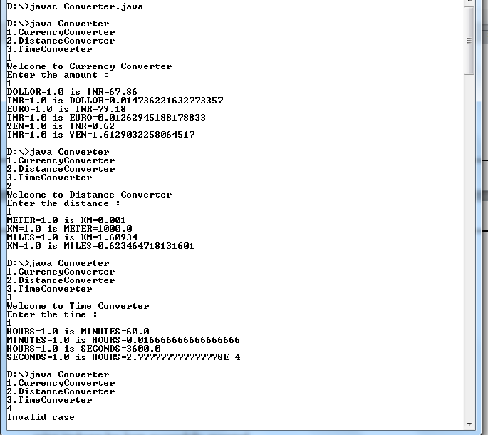

RESULT:

Thus the application for currency converter, distance converter and time converter using packages has been successfully executed.

Ex .no :3 GENERATING EMPLOYEE PAYROLL DETAILS

AIM:

To develop a java application for generating payslips of employees with their gross
and net salary.

ALGORITHM:

- The package keyword is used to create a package in java.
- Create a class Employee inside a package name employee.
- Class Employee contains Emp_name, Emp_id, Address, Mail_id,Mobile_no as members.
- By using Constructor initialize the instance variable of Employee class and display method is used to print employee details.
- Create classes Programmer, Assistant Professor, Associate Professor and Professor that extends Employee class and define necessary constructor fors ub classes.
- Each sub classes has its own instance variable like bPay and des.
- Override the paySlip method in each subclasses to calculate the gross and net salary
- By using super() method sub classes initialize the super class constructor.
- Import employee package and create the object for Empolyee class.
- Create different Employee object to add Array List<> classes.
11.Display Employee method is used to display all employee playSlip details

PROGRAM:

//For Packages,Folder Name should be employee
//File Name should be Employee.java

package employee;
public class Employee
{
private String name;
private String id;
private String address;
private String mailId;
private String mobileNo;
public Employee(Stringname,Stringid,String address,StringmailId,StringmobileNo)
{
this.name= name;
this.id= id;
this.address= address;
this.mailId=mailId;
this.mobileNo=mobileNo;

}
public void display()
{
System.out.println("Emp_Name : "+ name + "\t" + "Emp_id : "+ id);System.out.println("Address: " +address);
System.out.println("Mail_id:"+mailId + "\t"+"Mobile_no:"+mobileNo);
}
Public void paySlip()
{
}
}

//ForPackages, Folder Name should be employee
//File Name should be Programmer.java

package employee;
public class Programmer extends Employee
{
private float bPay;
private String des;
public Programmer(String name,String id,String address, String mailId,String mobile No,float bPay, String des)
{
super(name, id, address, mailId, mobileNo); this.bPay=bPay;
this.des=des;
}
Public void paySlip()
{
float da=bPay*97/100; float hra=bPay*10/100;
double grossSalary=bPay + da + hra; float pf=bPay*12/100;
double scf=bPay*0.1/100;
double netSalary=grossSalary-pf-scf;
System.out.println("------------EmployeesPaySlips ");
super.display(); System.out.println("Designation: "+des); System.out.println("Basic_Pay:"+bPay);
System.out.println("Gross Salary : "+ grossSalary + "\t" + "Net Salary : " + netSalary); System.out.println("------------EndoftheStatements ");
}
}

//ForPackages,Folder Name should be employee
//File Name should be AssistantProfessor.java

package employee;
public class Assistant Professor extends Employee
{
private float bPay;
private String des;
public Assistant Professor(String name, String id, String address, String mailId, String mobileNo,float bPay, String des)
{
super(name, id, address, mailId, mobileNo); this.bPay=bPay;
this.des=des;
}
public void paySlip()
{
float da=bPay*97/100; float hra=bPay*10/100;
double grossSalary=bPay + da + hra; float pf=bPay*12/100;
double scf=bPay*0.1/100;
double netSalary=grossSalary-pf-scf;
System.out.println("------------EmployeesPaySlips ");
super.display(); System.out.println("Designation: "+des); System.out.println("Basic_Pay:"+bPay);
System.out.println("Gross Salary : "+ grossSalary + "\t" + "Net Salary : " + netSalary); System.out.println("------------EndoftheStatements ");
}
}

//For Packages,Folder Name should be employee
//File Nam should be AssociateProfessor.java

package employee;
public class Associate Professor extends Employee
{
private float bPay;
private String des;
public AssociateProfessor(String name, String id, String address, String mailId, String mobileNo,float bPay, String des)
{
super(name,id,address,mailId,mobileNo);

this.bPay= bPay;
this.des=des;
}
public voidpaySlip()
{
float da=bPay*97/100;
float hra=bPay*10/100;
double grossSalary=bPay + da + hra;
float pf=bPay*12/100;
double scf=bPay*0.1/100;
double netSalary=grossSalary-pf-scf;
System.out.println("------------EmployeesPaySlips ");
super.display(); System.out.println("Designation: "+des);
System.out.println("Basic_Pay:"+bPay);
System.out.println("Gross Salary : "+ grossSalary + "\t" + "Net Salary : " + netSalary); System.out.println("------------EndoftheStatements ");
}
}

//For Packages,Folder Name should beemployee
//File Name should be Professor.java

Package employee;
Public class Professor extends Employee
{
private float bPay;
private String des;
public Professor(String name, String id, String address, String mailId, String mobileNo, floatb Pay,String des)
{
super(name, id, address, mailId, mobileNo);
this.bPay=bPay;
this.des=des;
}
Public void paySlip()
{
float da=bPay*97/100;
float hra=bPay*10/100;
double grossSalary=bPay + da +hra;
Float pf=bPay*12/100;
Double scf=bPay*0.1/100;
Double netSalary=grossSalary-pf-scf;
System.out.println("------------Employees PaySlips ");

super.display();
System.out.println("Designation:"+des);System.out.println("Basi_Pay:"+bPay);
System.out.println("Gross Salary : "+ grossSalary + "\t" + "Net Salary : " + netSalary);
System.out.println("------------EndoftheStatements ");
}
}

//FileNameshould beEmp.java separatethis filefrom abovefolder

importemployee.*;
import java.io.IOException;import java.util.ArrayList;import java.util.Scanner;publicclass Emp
{
Employeee;
ArrayList<Employee> obj= new ArrayList<>();Scanner get=newScanner(System.in);
publicvoidaddEmployee()
{
System.out.println("Enter the Emp_Name:");
String name = get.next();
System.out.println("Enter the Emp_id:");
String id = get.next();
System.out.println("Enter the Address:");
String address = get.next();
System.out.println("Enter the Mail_id:");
String mailId = get.next();
System.out.println("Enter the Mobile_no:");
String mobileNo = get.next();
System.out.println("Enter the Designation:");
String des = get.next();
System.out.println("Enter the Basic_Pay:");
float bPay = get.nextFloat();
if(des.equals IgnoreCase("Programmer"))
{
e= new Programmer(name, id, address, mailId, mobileNo, bPay, des);obj.add(e);
}
else if(des.equals IgnoreCase("Assistant Professor"))
{
e= new Assistant Professor(name, id, address, mailId, mobileNo, bPay, des);obj.add(e);

}
else if(des.equals Ignore Case("Associate Professor"))
{
e=newAssociate Professor(name,id,address,mailId,mobileNo,bPay,des);obj.
dd(e);
}
else if(des.equals Ignore Case("Professor"))
{
e= new Professor(name, id, address, mailId, mobileNo, bPay, des);obj.add(e);
}
}
Public void display Employee()
{
for(Employeee:obj)
{
e.paySlip();
}
}
Public static voidmain(Stringargs[])throws IOException
{
Emp x= new Emp();
Stringcheck;
do
{
x.addEmployee();
System.out.println("Do you wnat continue press 'y'");check=x.get.next();
}
while(check.equalsIgnoreCase("y"));x.displayEmployee();
}
}

NOTE:

ToCompile,gotoemployeefolder
javac Employee.javajavacProgrammer.java
javac AssistantProfessor.javajavac AssociateProfessor.javajavacProfessor.java
ToCompile, itshould beoutsidethe package
javacEmp.java
To Run
javaEmp

OUTPUT:
D:\>javac Emp.javaD:\>javaEmp
Enter the Emp_Name:
Suresh
Enter the Emp_id:
E708
Enter the Address:cuddalore
Enter the Mail_id:suresh708@tgarments.orgEnter the Mobile_no:7894561230
Enter the Designation:
Programmer
Enter the Basic_Pay:7500
Do you wnat continue press 'y'y
Enter the Emp_Name:
Rakesh
Enter the Emp_id:
E705
Enter the Address:pondy
Enter the Mail_id:rakesh@gmail.comEnter the Mobile_no:4567891230
EntertheDesignation:
Professor
Enter the Basic_Pay:15000
Do you wnat continue press 'y'y
Enter the Emp_Name:kumar
EntertheEmp_id:
E405
Enter the Address:madurai
Enter the Mail_id:

kumarat@ymail.comEnter the Mobile_no:1237894560
Enter the Designation:AssistantProfessor
Enter the Basic_Pay:18000
Do you wnat continue press 'y'y
Enter the Emp_Name:
Naresh
Enter the Emp_id:
E102
Enter the Address:villupuram
Enter the Mail_id:nar12@rediffmail.com
Enter the Mobile_no:9873214560
Enter the Designation:AssociateProfessor
Enter the Basic_Pay:20000
Do you wnat continue press 'y'n

------------EmployeesPaySlips------------
Emp_Name:Suresh Emp_id : E708Address: cuddalore
Mail_id:suresh708@tgarments.org Mobile_no : 7894561230Designation:Programmer
Basic_Pay:7500.0
Gross Salary: 15525.0Net Salary:14617.5
------------EndoftheStatements-----------
------------EmployeesPaySlips------------
Emp_Name:Rakesh Emp_id : E705Address : pondy
Mail_id:rakesh@gmail.com Mobile_no : 4567891230Designation:Professor
Basic_Pay:15000.0
Gross Salary: 31050.0Net Salary:29235.0
------------EndoftheStatements-----------
------------EmployeesPaySlips------------
Emp_Name: kumar Emp_id : E405Address: madurai
Mail_id:kumarat@ymail.com Mobile_no : 1237894560Designation:AssistantProfessor
Basic_Pay:18000.0
Gross Salary: 37260.0Net Salary:35082.0
------------EndoftheStatements-----------
------------EmployeesPaySlips------------
Emp_Name:Naresh Emp_id : E102Address: villupuram
Mail_id : nar12@rediffmail.comMobile_no : 9873214560Designation:AssociateProfessor
Basic_Pay:20000.0
Gross Salary: 41400.0Net Salary:38980.0
------------EndoftheStatements-----------

D:\>

RESULT:

Thustheapplicationforgeneratingpayslipsofemployeeswiththeirgrossandnetsalaryhas been successfullyexecuted.

Ex .no :4 DESIGNAJAVAINTERFACEFORADTSTACK

AIM:

ToDesignaJavainterfaceforADTStackandimplementthisinterfaceusingarray,
providenecessaryexception handlingin theimplementation.

ALGORITHM:

- Importthejavapackages.
- DesignaninterfaceforMytackwithfunctions push,popanddisplay.
- Defineaclass StackArraytoimplement theMyStackusingarray.
- Definethefunctionsoftheinterfaceaccordinglyandhandlethestackoverflowandunderflowexceptions.
- CreateaclassStackAdtandobjectforaclassStackArrayinmemoryandassignittothereferencevariable, then themethod is invoked.
- ByusingScannerclass getthechoices forswitch statement duringruntime.
- Byusingswitchcasestatementwecan push, popand displaytheelementsforeachchoice.

PROGRAM:

//FileNameshould beStackAdt.java

import java.util.Scanner;interfaceMyStack
{
public void pop();
public void push();
public void display();
}

classStackArrayimplementsMyStack
{
finalstaticintn=5;
int stack[]=new int[n];
inttop=-1;

publicvoid push()
{
Scanner in;try
{
in=new Scanner(System.in);
if(top==(n-1))

{
System.out.println(" Stack Overflow");
return;
}
else
{
System.out.println("Enter the element");
intele=in.nextInt();
stack[++top]=ele;
}
}
catch(Exceptione)
{
System.out.println("e");
}
}

Public void pop()
{
if(top<0)
{
System.out.println("Stackunderflow");
return;
}
else
{
int popper=stack[top];
top--;
System.out.println("Poppedelement:"+popper);
}
}

Public void display()
{
if(top<0)
{
System.out.println("Stack is empty");
return;
}
else
{
String str=" ";
for(int i=0;
i<=top; i++)str=str+""+stack[i]+"-->";

System.out.println("Elements are:"+str);
}
}
}

Class StackAdt
{
Public static voidmain(Stringarg[])
{
Scanner in= new Scanner(System.in);
System.out.println("Implementation of Stack using Array");
StackArraystk=new StackArray();
int ch=0;
do
{
System.out.println("1.Push 2.Pop 3.Display 4.Exit");
System.out.println("Enteryourchoice:");
ch=in.nextInt();
switch(ch)
{
case1:
stk.push();break;
case2:
stk.pop();break;
case3:
stk.display();break;
case4:
System.exit(0);
}
}
while(ch<4);
}
}

NOTE:

ToCompile,
javacStackAdt.java
To Run
javaStackAdt

OUTPUT:
D:\>javac StackAdt.javaD:\>javaStackAdt
Implementation of Stack using Array1.Push 2.Pop 3.Display4.Exit
Enter your choice:
1
Enter the element10
1.Push 2.Pop 3.Display 4.Exit
Enteryour choice:
1
Enter the element20
1.Push 2.Pop 3.Display 4.Exit
Enter your choice:
1
Enter the element30
1.Push2.Pop3.Display4.Exit
Enter your choice:
1
Enter the element45
1.Push 2.Pop 3.Display 4.Exit
Enter your choice:
1
Enter the element55
1.Push 2.Pop 3.Display 4.Exit
Enter your choice:
1
StackOverflow

1.Push 2.Pop 3.Display 4.Exit
Enter your choice:
3
Elements are: 10 -->20-->30 -->45 -->55-->

1.Push 2.Pop 3.Display 4.Exit
Enter your choice:
2
Popped element:55
1.Push 2.Pop 3.Display 4.Exit
Enter your choice:
3
Elements are:10 -->20-->30-->45-->

1.Push 2.Pop 3.Display 4.Exit
Enter your choice:
2
Poppedelement:45
1.Push 2.Pop 3.Display 4.Exit
Enter your choice:
3
Elements are:10 -->20-->30 -->

1.Push 2.Pop 3.Display 4.Exit
Enter your choice:
2
Popped element:30
1.Push 2.Pop 3.Display 4.Exit
Enter your choice:
3
Elements are:10-->20-->

1.Push 2.Pop 3.Display 4.Exit
Enter your choice:
2
Popped element:20
1.Push 2.Pop 3.Display 4.Exit
Enter your choice:
3
Elements are:10-->

1.Push 2.Pop 3.Display 4.Exit
Enter your choice:
2
Popped element:10

1.Push 2.Pop 3.Display 4.Exit
Enter your choice:
3
Stack is empty

1.Push 2.Pop 3.Display 4.Exit
Enter your choice:
3
Stack is empty

- Push 2.Pop 3.Display 4.Exit
Enter your choice:
4
D:\>

RESULT:

Thus the Implementation for ADT Stack interface using array has been successfully executed.

Ex .no :5 STRING OPERATIONS USING ARRAY LIST

AIM:

To write a java program to perform string operations using Array List.

ALGORITHM:

- Import the java packages.
- Define a class Array List and perform following functions:
  - Append- addat end
  - Insert-add at particular index
  - Search
  - List all string starts wit given letter
- Create an object for Array Lis to add string elements.
- By using Array List Method–add the elements are addedin to the Array List, the new element gets added after the last element unlessheind exis specified.
- The elements in Array List are displayed.
- Insert the specified element at the specified position index in this list.
- After inserting the elements in ArrayList,the elements are displayed.
- Search an object in Array List whether it is listed under this instance or not.
- Finally List all string starts with given letter in Array List and displays the elements.

PROGRAM:

//FileNameshould be ArrayList.java

import java.util.*;
public class ArrayList
{
Public static voidmain(Stringargs[])
{
ArrayList<String>obj=newArrayList<String>();

/* Append - add at end */obj.add("Arun");
obj.add("Balaji");
obj.add("Chandru");
obj.add("David");
obj.add("Elango");

System.out.println("\n"+"Elements in ArrayList:");
System.out.print("\t"+obj+""+"\n"+"\n");

/* Insert - add at particular index */obj.add(0,"Arujun");
obj.add(1,"Barath");

System.out.println("After Inserting Elements:"+"");
System.out.print("\t"+obj+""+"\n"+"\n");

/* Searching Elements in ArrayList */System.out.println("Search For Element:");
Scanner in = new Scanner(System.in);StringsearchStr=in.nextLine();
booleanans = obj.contains(searchStr);if(ans)
System.out.println("\t"+"ArrayList contains"+searchStr+"\n");
else
System.out.println("ArrayList does not contains"+searchStr);

/* List all string starts with given letter in ArrayList */System.out.println("Arraylistgetthestrings startingwithgivenletter:");
ArrayList<String>obj1=newArrayList<String>();
Stringstart= in.next();
for(inti=0;
i<obj.size();
i++)
{
if(obj.get(i).starts With(start.toUpperCase()))
{
obj1.add(obj.get(i));
}
}
System.out.print("\t"+obj1+""+"\n"+"\n");
}
}

NOTE:

ToCompile:
javacArrayList.java
To Run:
javaArrayList

OUTPUT:
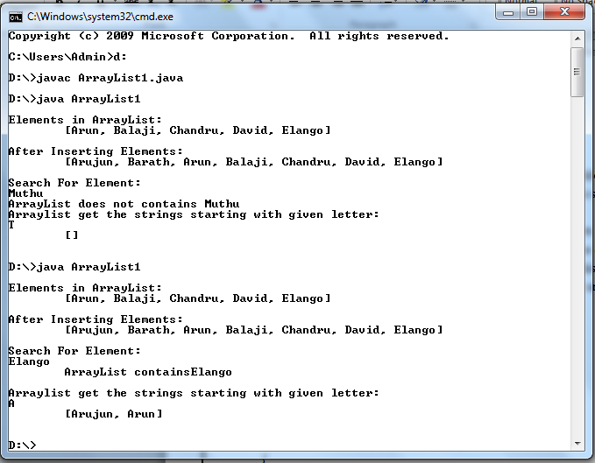

RESULT:
Thus the Implementation for string operations using ArrayList has been successfully executed.

Ex .no :6 FINDING THE AREA OF DIFFERENT SHAPES

AIM:

To write a java program to find the area of different shapes by using abstract class.

ALGORITHM:

- Import the java packages.
- Create an abstract class named Shape that contains two integers and an empty method namedprintArea().
- CreateaclassRectanglethatextendstheclassShape.OverridethemethodprintArea()bygettingWidthandLength thencomputethearea andprintstheareaoftheRectangle.
- CreateaclassTrianglethatextendstheclassShape.OverridethemethodprintArea()bygettingBaseandHeight then computethe area andprints theareaoftheTriangle.
- CreateaclassCirclethatextendstheclassShape.OverridethemethodprintArea()bygettingthe Radius, then computethe areaand prints the areaof theCircle.
- ByusingScanner class get theinput duringruntime.
- Create object for a class in memory and assign it to the reference variable, then the methodis invoked.

PROGRAM:

//FileNameshould be Area.java

import java.io.*;importjava.util.*;

abstractclassShape
{
double a=0.0, b =0.0;
abstractpublicvoidprintArea();
}

classRectangle extendsShape
{
double area = 0.0;publicvoidprintArea()
{
System.out.println("Area of Rectangle");System.out.println(" ");
Scanner in = new Scanner(System.in);System.out.println("Enter the Width:");this.a = in.nextDouble();System.out.println("EntertheLength:");

this.b=in.nextDouble();
this.area = a*b;/*(width*length)*/System.out.println("Theareaofrectangleis:"+this.area);
}
}

classTriangleextendsShape
{
double area = 0.0;publicvoidprintArea()
{
System.out.println("-----AreaofTriangle ");
System.out.println(" ");
Scanner in = new Scanner(System.in);System.out.println("Enter the Base:");this.a = in.nextDouble();System.out.println("Enter the Height:");this.b=in.nextDouble();
this.area=0.5*a*b; /*1/2 (base*height)*/System.out.println("Theareaoftriangleis:"+this.area);
}
}

classCircleextendsShape
{
double area = 0.0;publicvoidprintArea()
{
System.out.println("-----AreaofCircle ");
System.out.println(" ");
Scanner in = new Scanner(System.in);System.out.println("EntertheRadius:");this.a=in.nextDouble();
this.area = 3.14*a*a;/*3.14*r*r*/System.out.println("Theareaofcircleis:"+this.area);
}
}

publicclassArea
{
publicstaticvoidmain(String[]args)
{
System.out.println("-----FindingtheAreaofShapes ");
Shapes;
s=newRectangle();

s.printArea();s=new Triangle();s.printArea();s=new Circle();s.printArea();
}
}

NOTE:

ToCompile:

javacArea.java
To Run:

javaArea

OUTPUT:
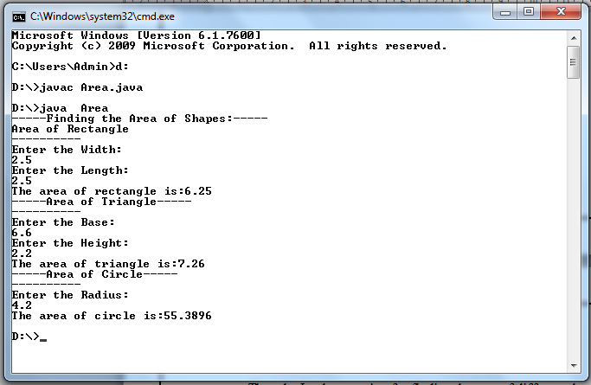

RESULT:

Thus the Implementation for finding the area of different shapes using abstract classhas been successfullyexecuted.

Ex .no :7 CREATINGOWNEXCEPTIONS

AIM:

Towriteajavaprogram toimplementuserdefinedexception handling.

ALGORITHM:

- Importthejavapackages.
- CreateasubclassofExceptionnamedasMyExceptionithasonlyaconstructorplusanoverloadedtoString() method thatdisplays the value of the exception.
- Theexceptionisthrownwhencompute()integer parameterisgreaterthan10.
- Themain()methodsetsupanexceptionhandlerforMyException,thencallscompute()withalegal value(lessthan10)and an illegalonetoshow both pathsthroughthecode.

PROGRAM:

//FileNameshouldbeUserException.java

import java.io.*;importjava.util.*;

classMyExceptionextendsException
{
privateint d;
MyException(inta)
{
d=a;
}

publicStringtoString()
{
return"MyException["+d+ "]";
}
}

classUserException
{
staticvoidcompute(inta)throwsMyException
{
System.out.println("CalledCompute("+a+")");if(a>10)
throw new MyException(a);System.out.println("NormalExit");
}

publicstatic voidmain(Stringargs[])
{
try
{
compute(1);compute(20);
}
catch(MyExceptione)
{
System.out.println("Caught "+e);
}
}
}

NOTE:

ToCompile:
javacUserException.java
To Run:
javaUserException

OUTPUT:
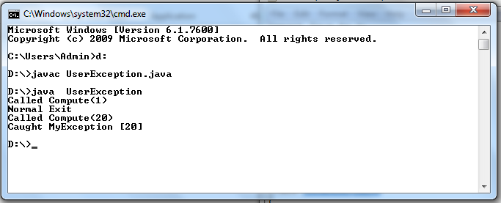

RESULT:

Thus the Implementation for user defined exception handling has been successfullyexecuted.

Ex .no :8 GETTINGFILEINFORMATION

AIM:

Towriteajavaprogramtoimplementfileinformationsuchasreadsafilenamefrom
theuser,displaysinformationaboutwhetherthefileexists,whetherthefileisreadable,orwritable,thetypeoffileand thelengthofthe filein bytes.

ALGORITHM:

- Importthejavapackages.
- ByusingScanner classget the input duringruntime.
- By using File class method create a File object associated with the file or directoryspecified by pathname. The pathname can contain path information as well as a file ordirectoryname.
- The exists() checks whether the file denoted by the pathname exists. Returns true if andonlyif thefiledenoted bythepathnameexists; false otherwise
- ThegetAbsolutePath() returns the absolute pathname stringof thepathname.
- ThecanRead()checkswhethertheapplicationcanreadthefiledenotedbythepathname. Returns true if and only if the file specified by the pathname exists and canberead bytheapplication; false otherwise.
- The canWrite() checks whether the application can modify to the file denoted by thepathname. Returns true if and only if the file system actually contains a file denoted bythepathnameandtheapplication isallowed to writeto thefile;false otherwise.
- The length() returns the length of the file denoted by the pathname. The return value isunspecifiedif thepathname denotes adirectory.
- The endsWith() returns true if the given string ends with the string given as argumentforthe method elseit returns false.
- The program uses conditional operator to check different functionalities of the givenfile.

PROGRAM:

//FileNameshould beFileInfo.java

import java.io.*;import java. util.*;publicclassFileInfo
{
publicstaticvoidmain(String[] args)throwsIOException
{
Scannerin=newScanner(System.in);

System.out.print("\nEnter the FileName: ");StringfName=in.next();

Filef=newFile(fName);
String result = f.exists() ? " exists." : " does not exist.";System.out.println("\nThegiven file "+fName+result);
System.out.println("\nFile Location: "+f.getAbsolutePath());if(f.exists())
{
result=f.canRead()? "readable.": "notreadable.";System.out.println("\nThefile is " +result);
result = f.canWrite() ? "writable." : "not writable.";System.out.println("\nThefile is " +result);
System.out.println("\nFilelengthis"+ f.length()+"inbytes.");

if(fName.endsWith(".jpg")||fName.endsWith(".gif")||fName.endsWith(".png"))
{
System.out.println("\nThegivenfileis animagefile.");
}
elseif(fName.endsWith(".pdf"))
{
System.out.println("\nThegivenfileis anportabledocumentformat.");
}
elseif(fName.endsWith(".txt"))
{
System.out.println("\nThegivenfileis atextfile.");
}
else
{
System.out.println("Thefiletypeisunknown.");
}
}
}
}

NOTE:

ToCompile:
javacFileInfo.java
To Run:
javaFileInfo

OUTPUT:
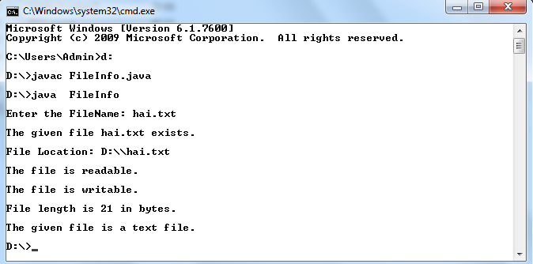
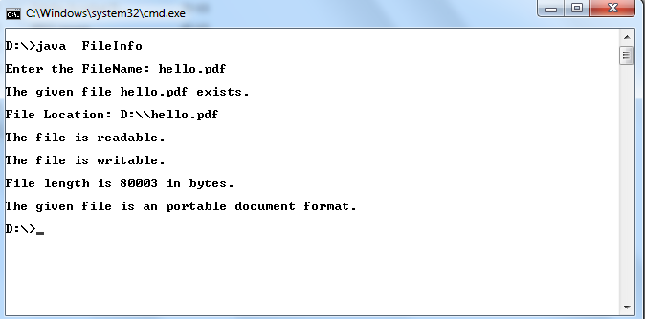
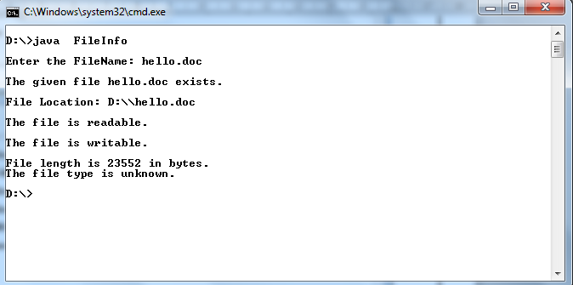

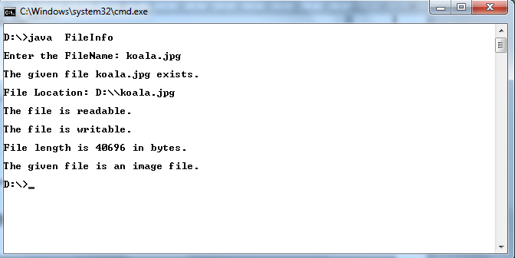

RESULT:

Thusthe Implementationfor gettingfileinformation hasbeensuccessfullyexecuted.

Ex .no :9 MULTITHREADEDAPPLICATION

AIM:

Towriteaprogramthatimplementsamulti-threadedapplicationthathasthree
threads. First thread generates a random integer every 1 second and if the value is even,second thread computes the square of the number and prints. If the value is odd, the thirdthreadwill print thevalueof cubeof thenumber.

ALGORITHM:

- Importthejavapackages.
- Createa threadthatgenerates randomnumber,Obtain one randomnumberandcheckisoddoreven.
- Ifnumberiseventhencreateandstartthreadthatcomputessquareofanumber,Computenumber* numberand displaytheanswer.
- Notifyto Random numberthread andgotostep 7.
- If numberisoddthen create andstartthreadthatcomputescubeof a number,Computenumber* number* number and displaytheanswer.
- Notifyto Random numberthread andgotostep 7.
- Waitfor1 SecondandContinuetoStep3 untiluserwants toexits.

PROGRAM:

//FileNameshould beMultithread.java

importjava.util.*;

classEvenimplementsRunnable
{
public int x;publicEven(intx)
{
this.x=x;
}
publicvoid run()
{
System.out.println("New Thread"+x+"isEVENand Squareof" +x+"is: "+x*x);
}
}

classOddimplementsRunnable
{
public int x;publicOdd(intx)

{
this.x=x;
}
publicvoid run()
{
System.out.println("New Thread"+x+"isODDand Cubeof"+x+"is:"+x* x*x);
}
}

classGenerateextendsThread
{
publicvoid run()
{
int num = 0;
Random r = new Random();try
{
for(int i =0; i<5; i++)
{
num=r.nextInt(100);
System.out.println("MainThreadGeneratesRandom Integer:"+num);if(num % 2 ==0)
{
Thread t1 = new Thread(new Even(num));t1.start();
}
else
{
Thread t2 = new Thread(new Odd(num));t2.start();
}
Thread.sleep(1000);
System.out.println(" ");
}
}
catch(Exceptionex)
{
System.out.println(ex.getMessage());
}
}
}

publicclassMultithread
{
publicstaticvoidmain(String[]args)
{
Generate g = new Generate();g.start();
}
}

NOTE:

ToCompile:
javacMultithread.java
To Run:
javaMultithread

OUTPUT:
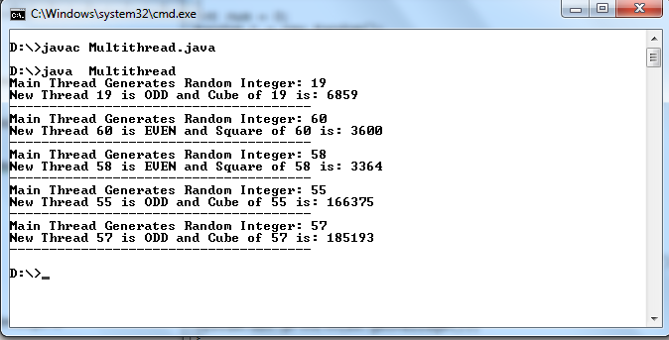

RESULT:

Thus the Implementation for application for multithreading has been successfullyexecuted.

Ex .no :10 GENERIC PROGRAMMING

AIM:

Towriteajavaprogramtofindthemaximumvaluefromthegiventypeofelements
usinga genericfunction.

ALGORITHM:

- Importthejavapackages.
- Comparableinterfaceisusedtoorder theobjectsofuser-definedclass.
- Thisinterfaceisfoundinjava.langpackageandcontainsonlyonemethodnamedcompareTo(Object).
- ThecompareTo()methodworksbyreturninganintvaluethatiseitherpositive,negative,or zero.
- Createagenericmethodmax(),that canacceptanytypeofargument.
- Thensetsthefirstelementasthemaxelement,andthencomparesallotherelementswiththemaxelement usingcompareTo()method
- Finallythefunction returns anelement which hasthe maximum value.
- Wecancallgenericmethodbypassingwithdifferenttypesofarguments,thecompilerhandleseach method.

PROGRAM:

//FileNameshouldbeMyGeneric.java

import java.util.*;classMyGeneric{
publicstatic<TextendsComparable<T>>Tmax(T...elements)
{
T max=elements[0];
for(T element :elements) {
if(element.compareTo(max) >0)
{
max =element;
}
}
returnmax;
}

publicstaticvoidmain(String[]args)
{
System.out.println("Integer Max: " + max(Integer.valueOf(32), Integer.valueOf(89)));System.out.println("String Max: "+ max("GaneshBabu", "Ganesh"));System.out.println("DoubleMax:"+max(Double.valueOf(5.6),Double.valueOf(2.9)));

System.out.println("Boolean Max: " + max(Boolean.TRUE, Boolean.FALSE));System.out.println("ByteMax:"+max(Byte.MIN_VALUE,Byte.MAX_VALUE));
}
}

NOTE:

ToCompile:
javacMyGeneric.java
To Run:
javaMyGeneric

OUTPUT:
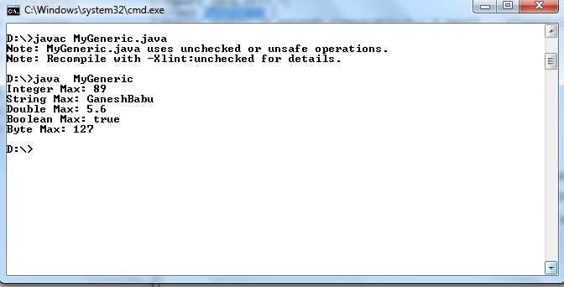

RESULT:

ThustheImplementationforfindingthemaximumvaluefromthegiventypeofelementsusingageneric functionhas beensuccessfullyexecuted.

Ex .no :11 EVENT-DRIVEN PROGRAMMING

AIM:

Towriteajavaprogram todesigna calculatorusing event-drivenprogramming
paradigmofJavawiththefollowingoptions.
    - Decimalmanipulations
    - Scientificmanipulations

ALGORITHM:

- Importthejavapackages.
- CreatetheclasscalculatorbyimplementingtheclassJframeandinterfaceactionListener.
- Declarethebuttons requiredusingJButton.
- Designthelayoutofthe calculatorusingthesetLayout,textpanel(),Panel(),Jtextfield(),setfont()methods.
- Definetheactionsto beperformed foreach keyusingActionListener.
- Enablethescientificor standardcalculator usingthemethodmethod add().
- Definethemathematicaloperationstobeperformedforthemathematicalsymbols.
- Selecttherequiredmathematicaloperationsusingswitchasthecalculator.
- Passtheparametersforthemethods used.
- Makethe frame visible byusingthe method setVisible().

PROGRAM:

//FileNameshouldbe ScientificCalculator.java

import java.awt.*;import javax.swing.*;importjava.awt.event.*;
importjavax.swing.event.*;
publicclassScientificCalculatorextendsJFrameimplementsActionListener
{
JTextFieldtfield;
double temp, temp1, result, a;static doublem1, m2;
int k = 1, x = 0, y = 0, z = 0;charch;
JButtonb1, b2, b3, b4,b5, b6, b7, b8, b9,zero,clr, pow2,exp,plus, min, div, log,rec,mul,eq, dot, sqrt, sin, cos, tan;
Containercont;
JPaneltextPanel,buttonpanel;

ScientificCalculator()
{
cont=getContentPane();cont.setLayout(newBorderLayout());JPaneltextpanel = new JPanel();tfield=new JTextField(25);
tfield.setHorizontalAlignment(SwingConstants.RIGHT);tfield.addKeyListener(newKeyAdapter() {
publicvoidkeyTyped(KeyEventkeyevent){charc=keyevent.getKeyChar();
if(c>= '0'&& c<='9'){
}else {
keyevent.consume();
}
}
});

textpanel.add(tfield);buttonpanel=newJPanel();
buttonpanel.setLayout(new GridLayout(8, 4, 2, 2));booleant = true;

b1 = new JButton("1");buttonpanel.add(b1);b1.addActionListener(this);

b2 = new JButton("2");buttonpanel.add(b2);b2.addActionListener(this);

b3 = new JButton("3");buttonpanel.add(b3);b3.addActionListener(this);

b4 = new JButton("4");buttonpanel.add(b4);b4.addActionListener(this);

b5 = new JButton("5");buttonpanel.add(b5);b5.addActionListener(this);

b6 = new JButton("6");buttonpanel.add(b6);b6.addActionListener(this);

b7 = new JButton("7");buttonpanel.add(b7);b7.addActionListener(this);

b8 = new JButton("8");buttonpanel.add(b8);b8.addActionListener(this);

b9 = new JButton("9");buttonpanel.add(b9);b9.addActionListener(this);

zero = new JButton("0");buttonpanel.add(zero);zero.addActionListener(this);

plus = new JButton("+");buttonpanel.add(plus);plus.addActionListener(this);

min = new JButton("-");buttonpanel.add(min);min.addActionListener(this);

mul = new JButton("*");buttonpanel.add(mul);mul.addActionListener(this);

div = new JButton("/");div.addActionListener(this);buttonpanel.add(div);

dot = new JButton(".");buttonpanel.add(dot);dot.addActionListener(this);

eq = new JButton("=");buttonpanel.add(eq);eq.addActionListener(this);

rec = new JButton("1/x");buttonpanel.add(rec);rec.addActionListener(this);

sqrt = new JButton("Sqrt");buttonpanel.add(sqrt);sqrt.addActionListener(this);

log = new JButton("log");buttonpanel.add(log);log.addActionListener(this);

sin = new JButton("SIN");buttonpanel.add(sin);sin.addActionListener(this);

cos = new JButton("COS");buttonpanel.add(cos);cos.addActionListener(this);

tan = new JButton("TAN");buttonpanel.add(tan);tan.addActionListener(this);

pow2 = new JButton("x^2");buttonpanel.add(pow2);pow2.addActionListener(this);

exp = new JButton("Exp");exp.addActionListener(this);buttonpanel.add(exp);

clr = new JButton("AC");buttonpanel.add(clr);clr.addActionListener(this);

cont.add("Center", buttonpanel);cont.add("North",textpanel);
setDefaultCloseOperation(JFrame.EXIT_ON_CLOSE);
}

public void actionPerformed(ActionEvent e) {Strings =e.getActionCommand();

if(s.equals("1")){
if(z==0) {
tfield.setText(tfield.getText()+"1");
}else {
tfield.setText("");

tfield.setText(tfield.getText()+"1");
z=0;
}
}

if(s.equals("2")){
if(z==0) {
tfield.setText(tfield.getText()+"2");
}else {
tfield.setText("");tfield.setText(tfield.getText()+"2");
z=0;
}
}

if(s.equals("3")){
if(z==0) {
tfield.setText(tfield.getText()+"3");
}else {
tfield.setText("");tfield.setText(tfield.getText()+"3");
z=0;
}
}

if(s.equals("4")){
if(z==0){
tfield.setText(tfield.getText()+"4");
}else {
tfield.setText("");tfield.setText(tfield.getText()+"4");
z=0;
}
}

if(s.equals("5")){
if(z==0) {
tfield.setText(tfield.getText()+"5");
}else {
tfield.setText("");tfield.setText(tfield.getText()+"5");
z=0;
}
}

if(s.equals("6")){
if(z==0) {
tfield.setText(tfield.getText()+"6");
}else {
tfield.setText("");tfield.setText(tfield.getText()+"6");
z=0;
}
}

if(s.equals("7")){
if(z==0) {
tfield.setText(tfield.getText()+"7");
}else {
tfield.setText("");tfield.setText(tfield.getText()+"7");
z=0;
}
}

if(s.equals("8")){
if(z==0) {
tfield.setText(tfield.getText()+"8");
}else {
tfield.setText("");tfield.setText(tfield.getText()+"8");
z=0;
}
}

if(s.equals("9")){
if(z==0) {
tfield.setText(tfield.getText()+"9");
}else {
tfield.setText("");tfield.setText(tfield.getText()+"9");
z=0;
}
}

if(s.equals("0")){
if(z==0) {
tfield.setText(tfield.getText()+"0");
}else {

tfield.setText("");tfield.setText(tfield.getText()+"0");
z=0;
}
}

if(s.equals("AC")){
tfield.setText("");x=0;
y=0;
z=0;
}

if(s.equals("log")){
if (tfield.getText().equals("")) {tfield.setText("");
}else {
a = Math.log(Double.parseDouble(tfield.getText()));tfield.setText("");
tfield.setText(tfield.getText()+a);
}
}

if(s.equals("1/x")){
if (tfield.getText().equals("")) {tfield.setText("");
}else {
a = 1 / Double.parseDouble(tfield.getText());tfield.setText("");tfield.setText(tfield.getText()+a);
}
}

if(s.equals("Exp")){
if (tfield.getText().equals("")) {tfield.setText("");
}else {
a = Math.exp(Double.parseDouble(tfield.getText()));tfield.setText("");
tfield.setText(tfield.getText()+a);
}
}

if(s.equals("x^2")){
if (tfield.getText().equals("")) {tfield.setText("");
}else {
a = Math.pow(Double.parseDouble(tfield.getText()), 2);tfield.setText("");
tfield.setText(tfield.getText()+a);
}
}

if(s.equals(".")){
if (y== 0) {
tfield.setText(tfield.getText() + ".");y=1;
}else {
tfield.setText(tfield.getText());
}
}

if(s.equals("+")){
if (tfield.getText().equals("")) {tfield.setText("");
temp = 0;ch= '+';
}else {
temp = Double.parseDouble(tfield.getText());tfield.setText("");
ch = '+';y=0;
x=0;
}
tfield.requestFocus();
}

if(s.equals("-")){
if (tfield.getText().equals("")) {tfield.setText("");
temp = 0;ch='-';
}else {
x=0;
y=0;
temp = Double.parseDouble(tfield.getText());tfield.setText("");

ch='-';
}
tfield.requestFocus();
}

if(s.equals("/")){
if (tfield.getText().equals("")) {tfield.setText("");
temp = 1;ch= '/';
}else {
x=0;
y=0;
temp = Double.parseDouble(tfield.getText());ch='/';
tfield.setText("");
}
tfield.requestFocus();
}

if(s.equals("*")){
if (tfield.getText().equals("")) {tfield.setText("");
temp = 1;ch= '*';
}else {
x=0;
y=0;
temp = Double.parseDouble(tfield.getText());ch='*';
tfield.setText("");
}
tfield.requestFocus();
}

if(s.equals("Sqrt")){
if (tfield.getText().equals("")) {tfield.setText("");
}else {
a = Math.sqrt(Double.parseDouble(tfield.getText()));tfield.setText("");
tfield.setText(tfield.getText()+a);
}
}

if(s.equals("SIN")){
if (tfield.getText().equals("")) {tfield.setText("");
}else {
a = Math.sin(Double.parseDouble(tfield.getText()));tfield.setText("");
tfield.setText(tfield.getText()+a);
}
}

if(s.equals("COS")){
if (tfield.getText().equals("")) {tfield.setText("");
}else {
a = Math.cos(Double.parseDouble(tfield.getText()));tfield.setText("");
tfield.setText(tfield.getText()+a);
}
}

if(s.equals("TAN")){
if (tfield.getText().equals("")) {tfield.setText("");
}else {
a = Math.tan(Double.parseDouble(tfield.getText()));tfield.setText("");
tfield.setText(tfield.getText()+a);
}
}

if(s.equals("=")){
if (tfield.getText().equals("")) {tfield.setText("");
}else {
temp1 = Double.parseDouble(tfield.getText());switch(ch){
case'+':
result = temp + temp1;break;

case'-':

case'/':

result = temp - temp1;break;

result=temp /temp1;

break;case '*':
result = temp * temp1;break;
}
tfield.setText("");tfield.setText(tfield.getText() + result);z=1;
}
}
tfield.requestFocus();
}

public static void main(String args[]) {try
{
UIManager.setLookAndFeel("com.sun.java.swing.plaf.windows.WindowsLookAndFeel");
}
catch(Exceptione)
{
}
ScientificCalculator f = new ScientificCalculator();f.setTitle("ScientificCalculator");
f.pack();f.setVisible(true);
}
}

NOTE:

ToCompile:
javacScientificCalculator.java
To Run:
javaScientificCalculator

OUTPUT:

Addition[12+64] | SquareRoot [16]
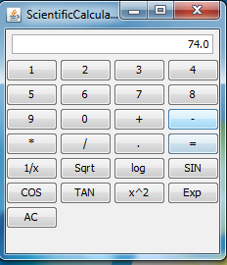 | 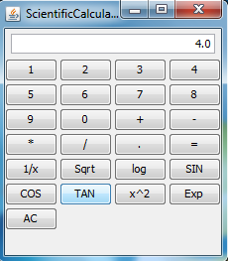
Tan45 | Log2
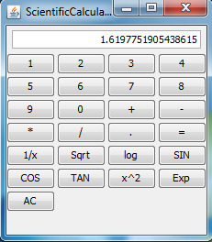 | 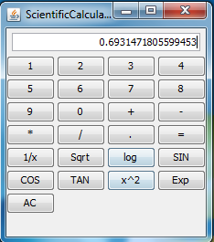

RESULT:

Thus the Implementation for designing the scientific calculator has been successfullyexecuted.

Ex .no :12 MINIPROJECT-OPACSYSTEM

AIM:

Todevelop amini projectOPACsystem forlibraryusingJavaconcepts.

ALGORITHM:

- Importthe awt,swingpackages.
- ExtendtheJFramewhich implementsactionlistenertotheclassdatas.
- Createthetextfieldforid,name and buttonfor next,addressandthe panel.
- Createobjectforthegetcontentpane().
- Assignthelengthandbreadthvalueforthelayoutusinggridlayout.
- Addthenew labelsforISBNand bookname.
- Add thenew buttonforthenextbook
- Create thebookname under the driver jdbcodbcdriverin thetryblock.
- Createtheobjectforexceptionas eand useit for catchingtheerror.
- Showalltherecords usingshowrecord.

PROGRAM:

//File Nameshould be Data.java

importjava.sql.*;import java.awt.*;import java.awt.event.*;importjavax.swing.*;
publicclassData extendsJFrameimplementsActionListener
{
JTextFieldid;
JTextFieldname;
JButtonnext;
JButtonaddnew;
JPanelp;
static ResultSet res;static Connection conn;staticStatement stat;
publicData()
{
super("My Application");Container c = getContentPane();c.setLayout(newGridLayout(5,1));

id = new JTextField(20);name=newJTextField(20);
next=newJButton("NextBOOK");

p=newJPanel();
c.add(newJLabel("ISBNNumber",JLabel.CENTER));c.add(id);
c.add(new JLabel("Book Name",JLabel.CENTER));c.add(name);
c.add(p);

p.add(next);next.addActionListener(this);pack();
setVisible(true);addWindowListener(new WIN());
}

publicstaticvoid main(Stringargs[])
{
Data d = new Data();try
{
Class.forName("sun.jdbc.odbc.JdbcOdbcDriver");conn=DriverManager.getConnection("jdbc:odbc:stu");
//custis theDSNName
stat=conn.createStatement();
res = stat.executeQuery("Select * from stu"); // stu is the table nameres.next();
}
catch(Exceptione)
{
System.out.println("Error"+e);
}
d.showRecord(res);
}
publicvoidactionPerformed(ActionEvente)
{
if(e.getSource()==next)
{
try
{
res.next();
}
catch(Exceptione)
{
}
showRecord(res);
}
}
publicvoidshowRecord(ResultSetres)
{
try

{
id.setText(res.getString(2));name.setText(res.getString(3));
}
catch(Exceptione)
{
}
}//endofthemain

//Inner class WIN implementedclassWINextendsWindowAdapter
{
publicvoidwindowClosing(WindowEventw)
{
JOptionPanejop = new JOptionPane();jop.showMessageDialog(null,"Thankyou","My
Application",JOptionPane.QUESTION_MESSAGE);
}
}
}

NOTE:
Createanew Database
- CreateanewDatabase fileinMSACCESS(ourbackend)named“books.mdb”.
- Thencreateatablenamed “stu” init.
- Thetablestucontains thefollowingfields anddatatypes
  - ISBN-Text
  - BookName-Text
- Entervariousrecords asyouwish.
- Savethedatabasefile.

Nextstepistoaddour“books.mdb”totheSystemDSN.Todothatfollowstheproceduregivenbelow,
  - GotoStart->ControlPanel ->Administrativetools.
  - Inthatdouble click“DataSources(ODBC)”.
  - ODBCDataSourceAdministrator dialogappears.
  - Inthatselect“SystemDSN”tabandclicktheAddButton.
  - Select“MicrosoftAccessDriver(*.mdb)”andclickFinish.
  - ODBCMicrosoftAccessSetupappears. Inthe “DataSourcename”type “stu”.
  - Click on the “Select” button and choose your database file. Then click ok.Now your databasefilegetsadded to theSystem DSN.

Table:Design View
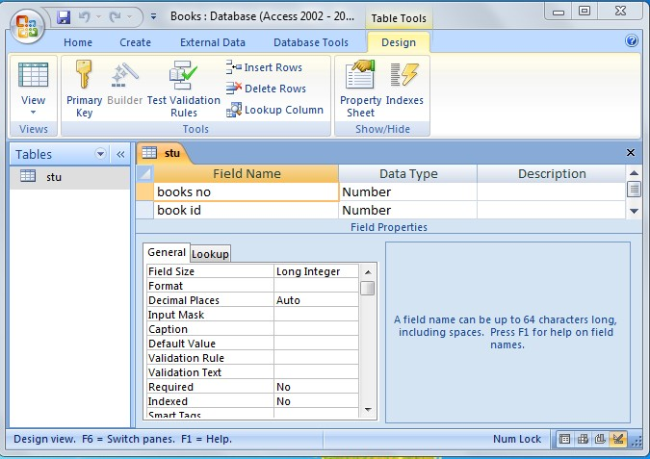

TableName:stu
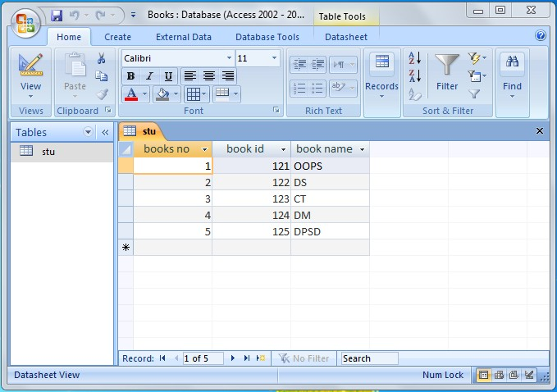

AdministrativeTools.
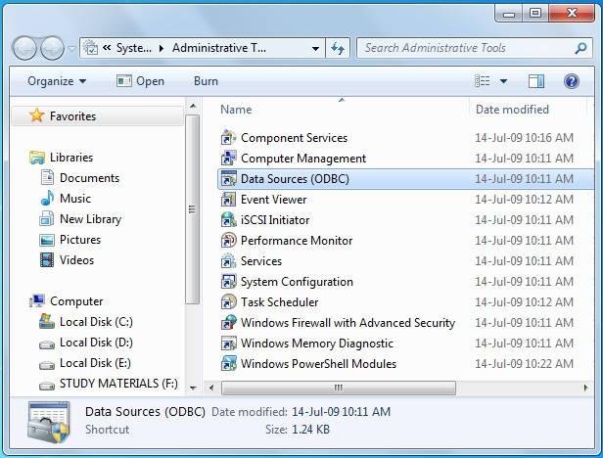

ODBCDataSourceAdministrator
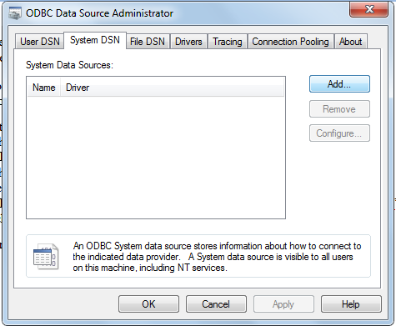

CreatingMicrosoftAccessDriver(*.mdb)
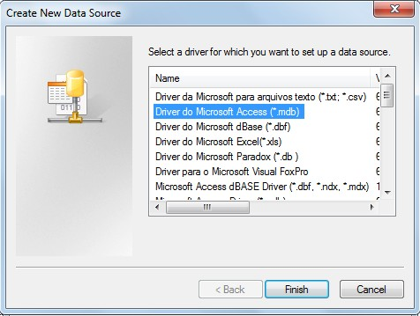

ODBCMicrosoftAccessSetup
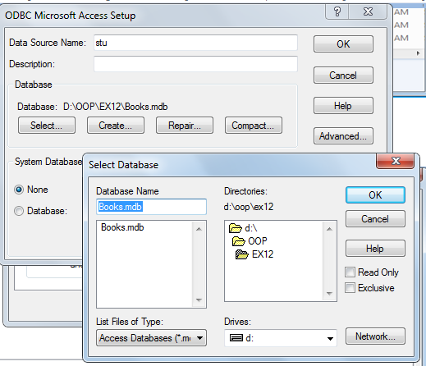

OUTPUT:

ToCompile:
javacData.java
To Run:
javaData

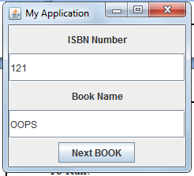
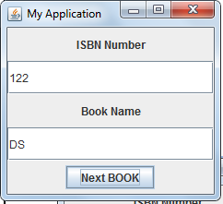

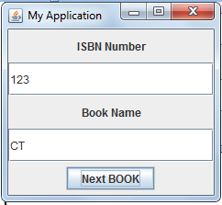
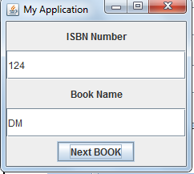

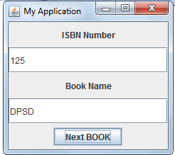

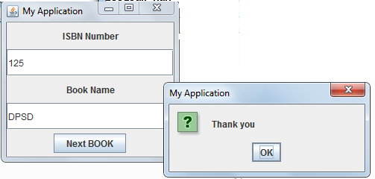

RESULT:

ThustheprogramtodevelopthesimpleOPACforthelibrariesisexecutedsuccessfully.

